***Experiment 6:***

**Operational Amplifiers and Their Applications**

Note::(Vcc of +12v and -12v should be given from the Power Supply's 3 terminal port, where the “COM / 0V” should be grounded.)

**Theory**

The op-amp is a very high gain amplifier. An ideal op-amp has infinite gain; a practical op-amp such as the LM741 will have a gain of close to 10,000. The output voltage is this gain times the difference of the two inputs, i.e., vout=A(v+in−v−in), where the value of A is something very very large.

Further, the inputs of the op-amp take no current. In ideal op-amps, the current drawn by the input terminals is zero; in LM741 it is very very small (of the order of μA); in modern op-amps it is zero.

Keeping the above two properties in mind, i.e. (1) very very high gain, and (2) no current drawn by the inputs, op-amp circuits are developed to perform a variety of functions. For any meaningful output voltage, the two input potentials have to be almost equal to each other.

When the difference between the two input potentials is not close to zero, the op-amp output voltage does not shoot to ±infinity; it is limited to the positive and negative power supply rail voltages.

**Procedure**

In this laboratory exercise we will study the following circuits:

1. Non-inverting amplifier
2. Inverting amplifier
3. Adder
4. Subtracter
5. **Non-inverting Amplifier:**
6. Choose R1 as 1 kΩ, and R2 as 10 kΩ to obtain a voltage gain of +11.
7. Apply a sinusoid input of amplitude upto 1 volt and observe the output along with the input.
8. Verify the operation at different frequencies. Check at frequencies upto 1MHz. At what frequency does the gain become lower than ideal?
9. At what input amplitude does the output of the amplifier saturate?
10. Now use R2 of 47kΩ to obtain a theoretical voltage gain of +48.
11. Apply a sinusoid input of amplitude upto 100mV and observe the output along with the input.
12. Verify the operation at different frequencies. At what frequency does the gain become lower than ideal?
13. At what input amplitude does the output of the amplifier saturate?

Voltage gain= 1+ (R2/R1)

Note::For a given gain and a given Vcc, estimate the input voltage that can be applied without saturating the output. Verify this experimentally.

**Circuit Diagram**

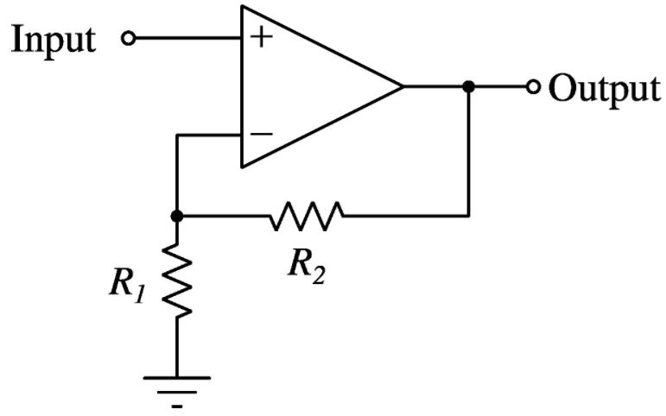

Figure 1: Non-inverting amplifier

**Observations**

1. **Inverting Amplifier**:
2. Choose R1 as 1 kΩ, and R2 as 10 kΩ to obtain a voltage gain of -10.
3. Apply a sinusoid input of amplitude upto 1 volt and observe the output along with the input.
4. Verify the operation at different frequencies. Check at frequencies upto 1MHz. At what frequency does the gain become lower than ideal?
5. At what input amplitude does the output of the amplifier saturate?
6. Now use R2 of 47kΩ to obtain a theoretical voltage gain of -47.
7. Apply a sinusoid input of amplitude upto 100mV and observe the output along with the input.
8. Verify the operation at different frequencies. At what frequency does the gain become lower than ideal?
9. At what input amplitude does the output of the amplifier saturate?
10. What do you observe when you connect the + terminal of the op-amp to the resistors, and the - terminal of the op-amp to ground (opposite of what is shown in the schematic)?

Voltage gain= - (Rf/Rin)

**Circuit Diagram**

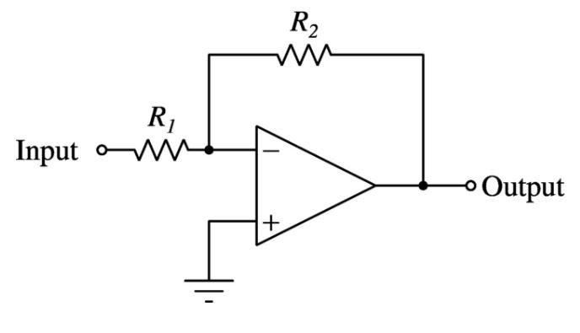

Figure 2: Inverting Amplifier

1. **Adder and subtracter circuits**

Setup the circuit as shown below.

1. Use R1 of 1kΩ and R2 of 10kΩ.
2. Apply two inputs at 1kHz and 5kHz. Set both amplitudes to less than 0.5 volts.
3. Observe the output on the DSO, and work out the relationship between the output and the two inputs.

Next setup the circuit as shown below.

1. Use R1 of 1kΩ and R2 of 10kΩ.
2. Apply two inputs at 1kHz and 5kHz. Set both amplitudes to less than 0.5 volts.
3. Observe the output on the DSO, and work out the relationship between the output and the two inputs.

**Circuit Diagram**

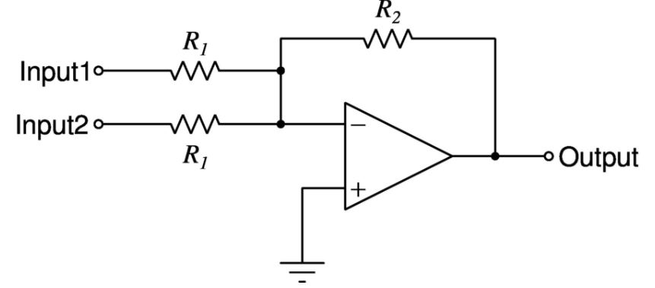

Figure 3: Adder Circuit

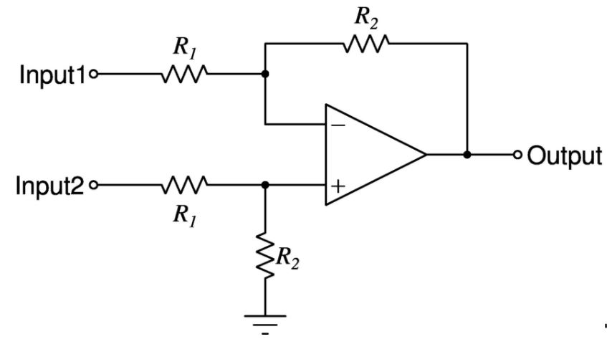

Figure 4: Subtracter circuit

**Conclusion:** In this experiment we studied different op-amp circuits and by varying the setup and frequency, resistance, etc. we established different

op amp circuits (namely voltage follower, inverting amplifier and non-inverting amplifier.)

First of all, we set up the voltage follower circuit where the input voltage is always equal to the output voltage irrespective of whatever we choose our input. This method is used to block the input impedances. The voltage gain in this type is 1. Then we had an inverting amplifier circuit where the output is out of phase with the input or is inverse of the input. The voltage gain in this case is -Rf/Rin. The inverting amplifier can also be used as a summing amplifier in applications like audio mixers. The inverting input forms a virtual earth, enabling several signals to be summed together. Lastly we encountered a non-inverting amplifier circuit where the output is in phase with the input and the voltage gain is given by (1+Rf/Rin). To sum up, in these circuits we learned different types of op-amps which are very important for an electrical engineer.